ANNUAL BUDGET FOR THE FINANCIAL YEAR ENDING 30 JUNE 2021

INTRODUCTION
The budget for the 2020/21 financial year has been drawn up in terms of chapter 4 of the Municipal Finance Management Act no.56 of 2003 (MFMA) and the Municipal Systems Act no. 32 of 2000 (MSA) on matters specifically related to the budget as well as direction from National Treasury on policy guidelines (MFMA Circulars).
The Medium Term Budget Policy Statement 2019 notes that the South African economic growth for 2019 is 0.5% However the economic statistics showed an unexpected improvement in the economic outlook. The municipalities must adopt a conservative approach when projecting their expected revenue and cash receipts as well as pay particular attention to managing of revenue effectively and carefully and evaluate all spending decisions, especially now that there has been a reduction on direct and indirect transfers to local municipalities. In generating capacity for spending on key municipal infrastructure, the municipalities will have to identify inefficiencies and eliminate non-priority spending.
The annual budget in respect of the 2020/21 financial year has been prepared according to the approved IDP / Budget Process Plan and consists of the following six processes:
- Planning: - Schedule key dates, establish consultation forums, review previous processes. The Executive Mayor has during August 2019 tabled a time schedule outlining key deadlines for reviewing the IDP, preparation, tabling and approval of the budget.

- Strategizing:- Review IDP; Set service delivery objectives (3 years); Consider local, provincial and national issues; Consider previous and current year performances; Consider economic and demographic trends; Review policies and consult on tariffs

- Preparing: - Prepare budget, revenue and expenditure projections; Draft and amend policies; Consider local, provincial and national priorities.

- Tabling: - Table draft budget (90 days prior to new financial year), IDP & Budget related policies; Consult and consider formal responses from local, provincial and national.

- Approving: - Council considers approval of the budget and related policies 30 days prior to new financial year.

- Finalising: - Publish approved Service Delivery and Budget Implementation Plan (SDBIP) as well as Annual Performance agreements and key indicators.

OUTCOMES OF CONSULTATIVE PROCESS

After Council’s approval of the annual budget on 25 March 2020, the following consultation processes and meetings in terms of section 23 of the MFMA were held with identified stakeholders on the contents of the budget as well as on measurable performance indicators for the 2020/21 budget year:
- IDP / Budget Strategic Session;
- Workshop with Council;
- Advertisement on a local newspaper ;
- Provincial engagement on the draft budget;
- National Treasury and other sector departments as prescribed by section 23 of the MFMA; and
- Submission of the final IDP and Budget to Council .

- SITUATIONAL ANALYSIS

The Northern Cape Province is the largest province geographically with a total area of 12, 384 square kilometers. (Statistics SA, 2016).
Frances Baard is situated in the north-eastern corner of the Northern Cape Province. The district is the most densely populated district with approximately 387, 741 people. It is bordered by 2 provinces namely the Free State in the east, the North West to the north and by two district namely Siyanda to the west and Pixley ka Seme to the south.
According to the 2016 community survey, FBDM ‘s growth rate has increased by 1.5% since 2011 (382083 – 387741). A slight growth in Solplaatje Local Municipality (248037 -255351); and Dikgatlong Local Municipality (46839-48164). Followed by a decline in Phokwane Local Municipality (63000 – 60168); and Magareng Local Municipality (24207- 24059). Magareng (24 203), Dikgatlong (46 842), Phokwane (63 000) and Sol Plaatje (248 042) (Statistics SA, 2011).
2.1 Demographic Composition:
Currently, the Frances Baard District has a total population of 387 741 people, which represents 32.5% of the Northern Cape population. The chart in figure 3 clearly illustrates that Sol Plaatje consists of the largest population in the district of 66%, followed by Phokwane (16%); Dikgatlong (12%); and Magareng with the least population of 6%..
According to the 2016 community survey, the Frances Baard District growth rate has increased by 1.5% since 2011 (382083 – 387741) (see figure 4 above). A slight growth in Sol Plaatje and Dikgatlong areas respectively (248037 -25535) and (46839-48164). Followed by a decline in Phokwane and Magareng areas (63000 – 60168) and (24207- 24059). The changes in population growth rate may be due to various reasons such as migration, new births, death tolls, etc.
The district population is relatively young with 69% of the population aged 40 years and younger. Those between the ages of 41 and 65-years account for 23% and only 7% of the population is of retirement age, i.e. 66 years and older. Although the statistics illustrated in table 1 depict that a large percentage of the district’s population comprises of young people, the education levels in the district do not tell a pleasant story. According to the community survey of 2016, the District comprises of large numbers of low levels of education. Table 2 exemplifies the state of education in the District.
It is alarming to note that only 5.04% of the population have Higher/National/Advanced certificates with Grade 12/Occupational certificate NQ or higher in the district, considering that education is one of the government’s key priorities, to ensure economic growth and stability and combat poverty in South Africa.
2.2 Economic Analysis:
The Frances Baard District has the strongest economic potential in the Northern Cape, accounting for 36% of the provincial GDP. The graph in figure 5 stipulates that the economy of the district consists of the primary sector (14%) (agriculture and mining), secondary sector (9%) (Manufacturing, electricity and construction) and tertiary sector (77%) (Trade, transport, financial and social services). The economic growth of the District has also not been a steady one. Figure 6 provides a clear description of the fluctuation of the economic growth.
In 2006 the GDP was 3.4% which saw a steady decline in 2009 to -4% due to the global recession. The slow growth from 2010 to 2012 was due to the global recession recovery and slow production in the primary and secondary sectors. Economic growth decreased from 2013 where it was 1.4% and in 2014 and 2015 to 0.4% and 0.3% respectively. This is due to a decline in domestic growth which severely affects the buying power of consumers in Frances Baard District which is a predominantly the services sector.
The District is still characterized by high rate of unemployment (39.4%). Phokwane (47.8%), Magareng (53.9%), Dikgatlong (44%) and Sol Plaatje (36.2%) as illustrated in figure 7. FBDM, through its local economic development initiatives seek to address such issues and improve the state of unemployment levels in the district.
2.3 Employment Analysis:
The Frances Baard DM had a high unemployment rate since 2010 and according to STATS SA 2016 the trend of unemployment rate has increased to (39.4%).
Magareng local municipality has the highest unemployment rate (53.9%) within the district as compared to the other local municipalities.
2.4 Basic Service Delivery – Infrastructure Services:
The District Municipality (DM) through the Programme Management and Advisory Services Unit and the Housing Unit continues to support the three local municipalities, i.e. Dikgatlong, Magareng and Phokwane in infrastructure services and developing human settlements and working towards accelerating the delivery of sustainable human settlements within the district. The DM does not have any functions in direct service delivery but provides support and capacity through the above-mentioned units.

- Water and Sanitation
The DM assists the local municipalities with operation and maintenance funding for water and sanitation to eradicate backlogs. Access to water is a constitutional right to everyone as stipulated by Section 27 (b) of the Constitution of South Africa 1996. Municipalities are mandated by amongst others the Municipal Structure Act 1998, the Municipal Structures Amendment Act 2000 and the Water Services Act 1999, to provide potable water to households within their areas of jurisdiction.

According to the Census 2011 survey by Statistics SA, it is estimated that about 5 493 households in the district have no access to water and about 16 317 households lack access to proper sanitation. (Census survey is conducted every 10 years and we suggest that the information should be updated next year after the 2021 survey).
- Electricity and Energy
The availability of energy remains a serious resource challenge. In the last ten years the communities’ access to electricity has significantly improved. Census 2011 survey indicates that over 85% of the households in the district have access to electricity for lighting. This leaves a gap of 14 743 households. FBDM has funded the electricity master plans for Dikgatlong, Magareng and Phokwane to help improve planning.
- Roads and Storm Water
The Rural Road Asset Management System (RRAMS) in the district will become partly operational in 2019. FBDM is currently part of this programme initiated by the national Department of Roads. The aim of this system is to provide information about the roads assets in local municipalities as well as conditional assessments. This will become an important tool to lobby for funding of future roads’ projects.

Through the RRAMS programme it has already been established that there are about 2 085 km of gravel roads and about 975 km of paved roads as part of the municipalities’ street networks. FBDM’s grader operating team assist with maintenance of gravel streets in the local municipalities. FBDM’s grader operating team assist with maintenance of gravel roads in the local municipalities.

Housing
The demand for housing has increased significantly and to address the housing backlogs Frances Baard District Municipality should promote development principles which are; spatial justice, spatial sustainability, efficiency, spatial resilience, and good administration of the district and local municipalities. The distribution of land uses in a municipality clearly outlines the spatial configuration of the municipality. The ideal outcome is to change the spatial footprint of the municipality (FBDM Housing Settlement Sector plan, 2017/18).

- Consumer Education
The educating of consumers on the human settlements processes and their responsibilities as homeownerscontinues to be an essential part of the human settlements programme. The district municipality will continue to plan for and conducted eight (8) Housing Consumer Education Workshops as part of the sustainable human settlements development process.

- Local Municipalities
The district and local municipalities continue to work collectively to ensure that the human settlements projects are completed within the specified timeframes. Support to the three local municipalities in the development of sustainable human settlements will continue by the Frances Baard District Municipality.

- Dikgatlong Local Municipality
The Delportshoop 217 project is progressing well and several houses are already under construction. The project suffered some setbacks with labour disputes, but this was resolved, and the project is back on track for completion in 2019.

- Magareng Local Municipality
The Ikhutseng 1000 housing project continues with the emphasis remaining on the completion of phases 2 and 3 of the project. The process to develop the military veterans’ houses is in progress and it is envisaged that construction will start in 2020.

- Phokwane Local Municipality
The Kingston 685 project continues to be hampered by slow construction progress. The district will continue to support this project.

Overall Challenges:
- The cost to eradicate backlogs is high and increasing annually;
- Municipalities in the district depend mainly on grant funding for infrastructure provision;
- The Blue and Green Drop percentages have also generally improved, but no Blue or Green Drop was achieved;
- The number of capacitated and skilled personnel in municipalities must be increased;
- FBDM also provides assistance with O&M funding, management of the O&M of electricity services in some municipalities still needs to improve;
- Some municipalities struggle to pay their ESKOM accounts which leads to disconnections and disruption of services;
- Some renewable energy projects have been implemented;
- The lack of bulk electricity networks in the rural areas makes it difficult for new electrical connections to households;
- Except for Phokwane LM, there are no road master plans for different municipalities. Municipalities do not have sufficient funds for maintenance of street and storm water;
- Municipalities do not have sufficient resources for road maintenance and spends large amounts on hiring road works machinery; and
- The conditions of provincial gravel roads within the district have deteriorated over the years due to the following reasons:-
- Insufficient funds allocated for road maintenance by the provincial departments;
- Continuous breakdowns of road works machinery; and
- Increased traffic volume has a negative influence on gravel roads.

  - Local Economic Development (LED):

Local Economic Development (LED) is an outcome; it is a continuous developmental process based on local initiative and driven by local stakeholders. It involves identifying and using local resources ideas and skills to stimulate economic growth and development. The aim of LED is to create an enabling environment that stimulates and fosters employment creation, entrepreneurial opportunities for residents, alleviate poverty and redistribute resources and opportunities to the benefit of all local residents. The purpose of Local Economic Development is to build up the capacity of a local area to improve its economic future and the quality of life for all. It is a process by which government, the private sector, labour and civil society work collectively to create better conditions for economic growth and employment generation. Local economic development encourages public, private and civil society sectors to establish partnerships and collaboratively find local solutions to common economic challenges. The LED process seeks to empower local participants to effectively utilize business enterprise, labour, capital and other local resources to achieve local priorities (e.g. to promote quality jobs, reduce poverty, generate municipal taxes etc). For LED to be successful, participants and practitioners should have knowledge of these actions and be committed to a process to achieve sustainable results.The district economy is still very much primary based and skewed towards the Sol Plaatje municipality economy. Sol Plaatje alone is responsible for just under 80% of the value addition in the district while the secondary sector contributes only around 7%.

There are LED Priority issues planned to grow and develop the district economy. Some of these initiatives are:
- Establishment of economic clusters;
- Establishment of incubation hubs in all local municipalities;
- Establishment of an Agri-park inclusive of the Farmer Production Support Units (FPSU) and the Rural Urban Market Centre (Sol Plaatje fresh produce market);
- Establishment of Business Support centres (SMMEs support one stop centres) in Magareng and Dikgatlong local municipalities (Phokwane one is completed);
- Support and development of SMMEs;
- Local Trade and investment promotion;
- Product development and marketing of locally produced products;
- Entrepreneurship promotion and development;
- Promotion and support of township economies; and
- Informal economy support program

Overall Challenges:
- Diversification of the District economy
The Secondary sector (Manufacturing, Electricity, gas, water and Construction) creates low number of jobs in the district and the sector’s job absorption is erratic having employed 14 339 in 1996, 7 769 in 2011 to 9 445 in 2015. This was job losses of 6 570 jobs over the period 1996 to 2011 and an increase of 1 677 between 2011 and 2015. This emphasises the fact that manufacturing and construction industries are quite small in the district and are not attracting investments. Fixed capital investment in manufacturing and mining has stagnated, indicating that Frances Baard and its surrounds is not considered a major manufacturing area that attracts long term fixed capital investment. This picture needs to drastically change if the district is to create the needed jobs and have a diversified economy. Diversifying the economy aims to maximize return by investing in different areas that would each react differently to the same economic shock(s).

- Low Skills Levels
The lack of appropriately skilled people is one of South Africa's principal drivers of the high unemployment rate. There has been clear evidence of a shift in the profile of the main economic sectors of the country over the past 2 decades, characterised by a decline in the share of primary and secondary sectors (which are labour intensive and can absorb unskilled labour) and an increase in the Tertiary sector (which requires skilled labour). This shift is also true for the FBDM, as seen in the production profile of the District. Given that the largest employers in the FBDM come from the tertiary sector, almost half of the people employed in the District are skilled (41.8%); there is however a large portion that is Semi- and Unskilled (36.1%).
A breakdown of the local municipal level shows that just less than 50% of Sol Plaatje's workforce is skilled and interestingly, this LM has the highest portion of highly skilled labour in the district, at 24.9%. The percentage of semi-and unskilled labour is highest within the Dikgatlong, Magareng and Phokwane LMs, at 57.2%, 41.7% and 54.7% respectively. Skills development is very critical if we are to grow at levels we desire and can absorb labour from the district. Skills levels are also a critical determinant of which industries we can realistically target and be competitive in. Because of this, skills development is identified in the LED strategy as one the most important areas that the District must improve.
- Low Economies of scale
Frances Baard has small household sizes with 21% of household living one person, 19% 2 people, 16% three people, 17% four people and household with five plus sizes making up only 27% of households. The district population density is 30.62 people per Km² which is quite low and thus necessitates that the production and output of the district needs to be more focused for export purposes, this can be both within SA and or abroad.

- Poor infrastructure for businesses
Infrastructure is critical for the development and growth of any business. Access to infrastructure generally enables and gives a location competitive or comparative advantage over other areas, especially if the infrastructure can reduce the costs of doing business. In creating an enabling environment for businesses, it thus becomes critical for local government to ensure that there is sufficient business infrastructure to support businesses. This can be termed economic infrastructure and ranges from access to affordable and conducive office and workshop space, roads, dams etc.

- Poor coordination and support for LED
All the LMs are currently implementing LED strategies that they adopted. All LMS and the FBDM have functional but not effective LED forums structures. The participation of private sector is lacking and this renders the LED forums ineffective. There is a lot of working in silos as it relates to sector development and support, as a result the rand value or investment into the different sectors by Government and development agencies is diluted.

Tourism

Tourism is one of the world’s largest growing industries and one of its fastest growing economic sectors. The tourism industry contributes largely towards regional development as it aids in diversifying economies and promotes the development of new economic activities. Tourism has significant impacts that are generated when tourism spending flows into the non-tourism sectors of the local economy, it has the ability to stimulate demand and production in other sectors of the economy and generate significant multiplier effects. Tourism is not only regarded as an important economic activity but is also recognised as an essential tool to promote mutual understanding and tolerance through the interactions between tourists and host communities which enable participants to learn about each other’s culture. Domestic tourism has the potential to foster social cohesion, as citizens travel to explore their own country and interact with their fellow citizens in the process. Furthermore, tourism has the potential to foster regional interaction. (National Tourism Sector Strategy, 2017). A functional and vibrant tourism sector can facilitate socio-economic growth through job creation, investment attraction, social development and small enterprise development. The Frances Baard District Municipality (FBDM) has identified tourism as a sector with great potential for economic growth in the region. The district offers exceptional natural, cultural and historical attributes which offers potential for the development of tourism. Unfortunately, these tourism assets have not been optimally utilised to generate a significant impact on economic growth and development in the region.
The District has identified the following priority projects for tourism development:
- Develop and improve potential and current historical and heritage products;
- Water / river based multi-use visitor facilities/ soft adventure experiences;
- Avi-tourism; and
- Development and promotion of tourism routes in the district.

Overall challenges:

- Lack of functional tourist information centres
Tourist information centres provide comprehensive tourist information about the destination, tourism attractions, accommodation, activities and services within the locality. It is essential that tourists have easy access to information on tourism products within the District; in this case tourist should be able to find information from readily available sources such as tourism offices, information boards, maps, and brochures. Currently there are fully functional tourism information centres in two of the local municipalities in the District.
As the internet has become an important source of information for travellers providing them with the opportunity to obtain information both directly from destinations and tourism businesses, the FBDM has developed a tourism website to assist with the provision of information on smaller towns in the district.
- Lack of brand awareness
The marketing of the FBDM tourism brand is the essential component of the success of the industry. Brand Awareness and marketing can grow the visitor numbers, increase their length of stay, increase spending, for the benefit of the destination and local communities. The FBDM Tourism brand and its associated products are being marketed through tourism and trade exhibitions, travel guide, tourism website, local events, advertorials in renowned tourism publications and the distribution of branded promotional material at various platforms.
- Community Involvement
Tourism must involve the local communities and other stakeholders; through ownership and participation of tourism businesses for the economic benefits and job creation. In an effort to meaningfully increase local benefits, particularly within host communities living in areas where tourism potential exists, effective business and enterprise development is required. FBDM conducts annual community awareness campaigns to provide information on the benefits of the sector and avenues, incentive grants and financial support which are available to new tourism entrepreneurs entering the market.
- Local Tourism associations
Tourism development, marketing and management within the local municipalities currently take place in a largely uncoordinated manner. There are several tourism stakeholders operating within the district, (at local municipalities) including private sector stakeholders and the provincial tourism authority. Currently, there is little interaction between these stakeholders resulting in duplication of efforts as well as missed opportunities to grow the sector. The establishment of associations and forums at local municipalities and at district and provincial level aims to address these challenges and raise awareness of the benefits of the sector.
- Packaged Tourism experiences (Route development)
Route development represents a significant opportunity for the region. Routes play a strategic role in linking different regions and products and can facilitate movement of tourists through a region. The Frances Baard District benefits from the N12 Treasure Route which stretches from the Western Cape to Mpumalanga and runs through Kimberley and Warrenton, however there is still a need for further routes to be established in the region to address the shortage of packaged products and experiences.

- Sustainable tourism
Sustainable Tourism are an effort to reach a common understanding and represent the minimum sustainability principle that a tourism company should aspire to, we must encourage tourism activities that are respectful of natural, cultural and social environment and that align with the values of the community and permit a positive exchange of experiences between residents and visitors.

  - Environmental Management:

Municipal Health Services focus on the monitoring of environmental conditions that may have a detrimental impact on human health. The following legislation is applicable for the rending of Municipal Health Services:
- The Constitution of the Republic of South Africa 1996 ;
- The Municipal Systems Act, 2000 (Act 32 of 2000);
- The Municipal Structures Act, 1998 (Act117 of 1998);
- The Municipal Finance Management Act, 2000 (Act 56 of 2000);
- The National Health Act, 2003 (Act63 2003) and promulgated Regulations;
- Health Professions Act, 1974 (Act56 of 1974): Regulation 123 of 8 Feb 2008 Regulations defining the scope of the profession of Environmental Health: Amendment;
- Tobacco Products Control Act, 1993 (Act83 of 1993);
- The Foodstuffs, Cosmetics and Disinfectants Act and Regulations, 1972 (Act 54 of 1972) and promulgated Regulations;
- The National Building Regulations and Building Standards Act, 1977 (Act 103 of 1977);
- Hazardous Substances Act, 15 of 1973;
- Frances Baard District Municipality Municipal Health By-Laws;
- National Environmental Management Act, 1998 (Act107 of 1998);
- Disaster Management Act, 2002 (Act57 of 2002);
- The Meat Safety Act, 2000 (Act40 of 2000);
- Fertilizers, Farm Feeds, Agricultural and Stock Remedies Act, 1947 (Act 36 of 1947);
- Water Services Act, 1997(Act 108 of 1997): SANS 241;
- National Water Act,1998(Act 36 of 1998);
- Children’s Act and Regulations Act, 2005 (Act 36 of 2005);
- National Environmental Health Norms and Standards for premises and Acceptable Monitoring Standards for Environmental Health Practitioners, Notice 1229 of 2015;
- National Environmental Health Policy, 2013; and
- National Environmental Health Strategy, 2016.

Alignment with provincial and National Objectives/Goals
Section 24 of the Constitution of the Republic of South Africa, 1996 (No 108 of 1996) guarantees every citizen the right to an environment that is not harmful to their health and well-being. According to the Constitution of the Republic of South Africa 1996, the Local Government: Municipal Structures Act No.117 of 1998 and the National Health Act, No. 61 of 2003 it is the statutory responsibility of the District Municipality to render Municipal Health Services, which include:
- Water Quality Monitoring;
- Food Control;
- Waste Management;
- Health Surveillance of premises;
- Surveillance and prevention of communicable diseases;
- Vector Control;
- Environmental Pollution Control;
- Disposal of the dead; and
- Chemical Safety.

The objectives includes the promotion of healthy communities by assisting to reduce child mortality, increase life expectancy and improve hygienic conditions in the district through identification, evaluation and control of environmental conditions that can have a detrimental effect on the health and well-being of communities and the provision of health and hygiene education and awareness activities to promote a healthy lifestyle in communities.

Projects and Programs

- Food safety
The objective of this program is to promote the safe handling, preparation, storage and selling of foodstuffs by all food handlers (formal and informal). The Five keys to Safer Food – program is also implemented at food-handling/preparation premises (school-kitchens, Early Childhood Development Centres, vendors at taxi ranks caterers) to prevent the outbreak of food-borne diseases. Non-conformance at tuckshops from foreigners due to language barriers and the fact that owners/workers changing regularly.

- Water quality monitoring
Drinking water samples are collected on a monthly basis from communities, schools and clinics in Dikgatlong, Magareng and Phokwane local municipalities. Failures still do occurs due to poor management of water purification plants/systems. Above risk will be addressed through increasing water monitoring programmes; regular reporting to Water Services Authority and other relevant departments and stakeholders, and increasing awareness programs.

- Air quality management
The municipality have an Air Quality Management Plan in place which focus on the improvement of air quality in the district by identifying and reducing the negative impact of air pollution on people’s health and well-being and on the environment. Campaigns are conducted in communities and schools to sensitise the community and learners on air pollution and how to mitigate the effects thereof on human health.

- Waste management
Poor waste management continue to be a challenge in the district, due to poor management of landfill sites, illegal dumping of waste on open spaces and littering. Above challenges will be addressed through increase of landfill sites; increase awareness and education programmes, enforcement and increasing clean-up campaigns.
Health Care Risk waste in the district is handled by an accredited service provider who is also contracted by the Department of Health to collect and transport the waste from clinics and hospitals. They only accept waste in approved containers and transport the waste to an incinerator Gauteng.
Recycling of waste in the district is done on a limited scale and the separation of waste at household level will be promoted.

- Environmental Management Framework
The Frances Baard District Municipality strongly stand by the Constitution of the Republic of South Africa, 1996, article 24 (b) –(c), where it is stated that “everyone has the right to have the environment protected, for the benefit of present and future generations, through reasonable legislative and other measures that prevent pollution and ecological degradation; promote conservation; and secure ecologically sustainable development and use of natural resources while promoting justifiable economic and social development”
FBDM has developed an Environmental Management Framework (EMF) to proactively identify areas of potential conflict between development proposals and critical/sensitive environments. The EMF has been reviewed and will be gazetted to ensure that it is implemented effectively.

- Climate Change
The Frances Baard district’s biological diversity and natural resources are under threat from climate change, pollution, overexploitation of natural resources, invasion by alien species and escalating development. It is therefore imperative for FBDM to address these threats and their impacts through implementation of the Frances Baard Climate Change Vulnerability Assessment and Climate Change Response Plan which was developed with the assistance of the Deutsche Gesellschaft fur Internationale (GIZ) organization.

Overall Challenges:
- New environmental health challenges and risks are emerging which require complex solutions. Advances in technology, population growth, changes in standard of living, increase in industrialization, urbanisation and climate change are some of the factors that lead to emergence of challenges in environmental health;
- Municipal Health Services is a personnel driven function due to the fact that monitoring, according to the scope of practice of environmental health, form the basis of performing this function. With the additional functions of inspections at state premises, it is of critical importance to ensure that Frances Baard DM complies with the South African National Norms & Standards and World Health Organisation (WHO) ratio of one Environmental Health Practitioner for every 10 000 of the population within the region. Within the next 5 years we need to perform all 9 Key Performance Areas (KPA’s), however the water quality monitoring, waste management, food control, environmental pollution control and surveillance and prevention of communicable diseases need special attention to minimize our burden of diseases and increase life expectancy within our region; and
- The lawless nature of the public makes enforcement of legislation difficult. This gives rise to possible unsafe work environment for EHP’s to execute their duties.

  - Disaster management and fire services:

The Disaster Management Act, Act 57 of 2002, states that all municipalities should provide for: “An integrated and co-ordinated disaster management policy that focuses on preventing or reducing the risk of disasters, mitigating the severity of disasters, emergency preparedness, rapid and effective response to disasters and post disaster recovery”. Community-based disaster risk management is an approach which aims to reduce local disaster risks through the application of participatory assessment and planning methods. It is a practical bridging strategy to integrate local development efforts on one hand with strategies that reduce the impact of priority disaster risks on the other. The Frances Baard District Municipality (FBDM) support three local municipalities in its jurisdiction, namely Phokwane, Magareng and Dikgatlong to implement the Disaster Management Act. In addition, volunteers are trained on an annual basis to be deployed during any disaster. The FBDM adopted a contingency fund policy to assist destitute families within its jurisdiction. The National Disaster Management Framework emphasise that the district municipality had to perform its mandate as per the four key performance areas and three enablers to ensure effective implementation of the disaster management function. The District Disaster Management Plan and the individual disaster management plans for Magareng, Phokwane and Dikgatlong Local Municipalities were reviewed. The District Disaster Management Advisory Forum and the Local Municipal Disaster Management Advisory Forums are operational in the above-mentioned local municipalities. The lack of firefighting facilities and capacity (human and capital) in the district remains a challenge. Four fire protection associations are established within the district and operates under the Veld and Forest Fires Act (Act 101 of 1998) to assist with combatting veldfires. FBDM has a maintenance programme in place to assist farmers with the maintenance of veldfire equipment.

- Establishment of firefighting facilities within the FBDM jurisdiction
The possibilities of establishing firefighting facilities at local municipal level has been investigated. It was found that the best way to address the issue was through the establishment of the services at the municipality with the highest risk and highest population. The identified local municipality is Phokwane for the current period.

- Establishment of the District Disaster Management Centre
It is a requirement as per the Disaster Management Act (Act 57 of 2002) to establish a disaster management centre which must serve all its municipalities.
The district municipality concluded the planning stages for the establishment of the District Disaster Management Centre, however funding for this project remains a challenge. FBDM continues to explore different avenues towards realisation of a District Disaster Management Centre.

- Funding Resources
Conditional grants received from Province are as follows:
- Disaster Grant (conditional grant from province)

The disaster grant is used to implement the following:
- Response and recovery during incidents at local municipal level;
- Assistance to communities when affected by any incident;
- The training of volunteers at local municipal level; and
- Awareness programmes.

Overall challenges:
- The establishment of the District Disaster Management Centre;
- Local municipalities do not budget for contingencies;
- The availability of human capital and equipment to execute firefighting function and to respond as per SANS 10090 (Community Safety);
- The establishment of Fire stations in Phokwane, Magareng and Dikgatlong;
- Assistance to emerging farmers with regards to veldfires; and
- Local municipalities not belonging to a Fire Protection Associations.

  - Human Resources Development
The District Municipality structure consists of one hundred and sixty six (166) employees including 26 councillors (15 females and 11 males). Eight (8) females and eleven (14) males occupy management positions. Currently, 31 posts are vacant. Figure 9 consists of the municipality’s organogram.

- Human Resource Strategy
Our Human Resources Strategy is an elaborative plan of action which includes detailed pathways to implement Human Resources strategic plans and Human Resources plans. Each of these aspects have its own part within the overall strategic plan of the organization. For the successful implementation of the Human resources strategy we have four vital tasks that must be accomplished:
- Helping employees understand the strategy and comprehend the reason for the strategy;
- Augmenting employee commitment to the strategy;
- Streamlining employee dedication to the strategy; and
- Realigning inter-departmental relations within the municipality.

- Human Resource Development
The objective of Skills Development is to create a workforce empowered with the necessary and continuously upgraded skills, knowledge and qualifications in order to increase productivity and competency levels of employees. One of the strategies employed to become a peer leader in this category of employers, is amongst others, creating an environment conducive to learning and development by allocation of adequate resources for purposes of employee education, training and development, as well as retention of critical and scarce skills. FBDM has accommodated at least 1% in its budget for continuous investment in employees, Councillors as well as the unemployed communities, particularly youth, through training development initiatives.
- Labour Relations
The stabilization of the workforce is engendered through sincere, open, transparent consultation and engagement process about matters of mutual interest between employer and representatives organized labour.
The Local Labour Forum (LLF) is a forum comprising of equal representation between the employer representatives and serves as a dispute resolution and consultative structure.

The LLF, as a conflict resolution and consultative forum, of FBDM been clearly established and is fully functional. With a stable, active and properly functional LLF in place, the focus is to be directed at the maintenance of its active and functional status for the sustainability of its operations. A plan, which is to be embedded in the HR strategy, shall be implemented to ensure that the momentum of the current operational efficiency is maintained.

- Employment Equity
The Employment Equity Act No. 55 of 1998, as amended, requires all eligible employers to develop, approve, and submit a legally compliant employment equity plan (EEP). The EEP is a coordinated and structured initiative that seeks to respond to the obligation imposed on all employers for the removal of unfair discrimination and implementation of affirmative action measures all with the intent of leveling the playing field for the accessibility of opportunities by all in the workplace. The primary beneficiaries of EE are intended to be designated groups, particularly women and people living with disabilities.

- Health and Safety
The function of occupational health and workplace safety is governed by the Occupational Health and Safety Act and Regulations No. 85 of 1993. The Act provides for the nomination of safety representatives and the establishment of a workplace health and safety committee.
- Employee assistance and wellness
FBDM is constantly striving towards the ideal of becoming a hub of service excellence and a world class municipality. This feat may be achieved by and through, amongst others, the creation and maintenance of a content, satisfied and healthy workforce. In attempt to respond to this lofty ideal, the FBDM introduced a wellness and employee assistance programme (EAP). The ethos of professionalism and principle of confidentiality underpin the administrative handling and management of EAP within FBDM. To ensure that this crucial element of confidentiality is always observed and maintained, the services of externally based trained specialists and professionals are utilized.

- Recruitment and Selection
The staff establishment of any institution is and should be designed to carry out and implement its strategic objectives, and should also be responsive to and give support to the implementation of its strategic plan (IDP).
FBDM remains attentive to an effective recruitment and selection process. These processes include matching up the right person with the right job skills. Intensive interviews and background checks assist in identifying candidates who are most suitable to ensure that vacancies are filled with individuals who shares and endorses the company values and will fit in well within the company culture.

Overall Challenges:
- The recruitment and retention of scarce and critical skills remain a challenge for FBDM. To deal with this challenge with a view to stabilizing the workforce and stem the loss of talent, a policy on the retention of scarce and critical skills had been developed and approved. An implementation plan for the administration of the policy is to be developed;
- Despite the utmost professionalism with which the function is being handled, EAP is still regarded with skepticism and beset with credibility challenges and afflicted by negative stigma by the workforce of FBDM. In the endeavor to deal and reverse the challenge of negative perception and debilitating stigma, a well plan will be put in place to positively market EAP and internally brand FBDM as a caring institution which has the welfare of its employees at heart;
- The challenge experienced currently is the lack of general safety awareness and health consciousness amongst staff. This gap will be addressed through the development and rollout of suitable health and safety awareness programmes and campaigns; and
- The looming challenge, however, is in respect of the difficulty of recruiting people living with disabilities. Despite all efforts, people living with disabilities continue to not be responsive to the recruitment advertisements of FBDM. To redress this anomaly, a plan is to be established and implemented. The plan will, amongst other remedial actions, contain initiatives intended to ensure that all recruitment adverts are understandable, user-friendly, and have an appeal towards women and people living with disabilities, including having a wide reach and coverage of the entire district.

- DISTRICT–WIDE PRIORITY ISSUES:

The district-wide priority issues take into consideration the priority issues of the local municipalities. The combination of local municipalities priority issues to produce district priority issues strengthens the process of alignment between the district integrated development plan and the IDP’s of local municipalities.

On this basis the district-wide priority issues for 2020/21 are summarized as follows:

PRIORITY ISSUES – 2020/21
- Water and Sanitation;
- Roads and storm water;
- Housing & Land Development;
- Electricity;
- Township establishment;
- Disaster Management;
- Environmental Management;
- Health;
- Local economic Development &Youth Development; and
- Clean Audit.

4. ALIGNMENT WITH NATIONAL, PROVINCIAL AND DISTRICT PRIORITIES

Local government as the “implementation hub” of the government’s vision, it is incumbent that there be synergy across all spheres of government’s plans in order to achieve maximum impact in resource allocation and project implementation. The prioritization of needs, allocation of resources and the implementation of projects within and between the three spheres of government should be aligned and harmonized. It is through this “concept” that planning at national, provincial and local level relates and informs one another.

Alignment is built upon the following:
- The shared and common platform critical to alignment is made possible through a coherent set of national spatial guidelines based on the twin concepts of development potential and need;
- The normative principles and guidelines embodied in the National Spatial Development Perspective provide the central organising concept for facilitating alignment and serve as the concrete mechanisms and basic platform for better coordination and alignment of government programmes; and
- The spatial perspective is at the centre of our view of alignment and coordination and is directed at facilitating discussions on the development potential of the space economy and serving as a frame of reference for guiding government actions. (Presidency)

Each of the three spheres of government has planning tools used in the execution of its mandate. At the national level there are: the National Development Plan (NDP) 2030, the Medium Term Strategic Framework (MTSF) 2014-2019, the National Spatial Development Perspective (NSDP) , the New Growth Path (NGP) and Service Delivery Agreement e.g.: Outcome 9 to mention only a few. At the provincial level it is the Provincial Growth and Development Strategy (PGDS) and Strategic Plans of individual departments, and at the municipal level it is the Integrated Development Plans (IDP’s) and DGDS.

5. STRATEGIC OBJECTIVES

Informed by the district municipality’s Turn-around Strategy and the Local Government: Municipal Performance Regulations for Section 56 employees, the following strategic objectives were formulated:

KPA 1: Basic Service Delivery
Programme Management and Advisory Services
Goal: Improved access to sustainable basic services in the District.
Objective:
- To assist LM’s with infrastructure upgrading, operations and maintenance;
- To create job opportunities for the unemployed through the promotion of EPWP principles;
- To support improved infrastructure planning in the district; and
- To support the provision of potable water, sanitation facilities, electricity and streets and storm water households in the district.

Goal: Facilitate the creation of sustainable human settlements in the district.
Objective:
- To facilitate the reduction of the housing backlog;
- Monitoring of human settlements development in 3 LMs; and
- To capacitate human settlements consumers on human settlements requirements, processes and services.
KPA 2: Local Economic Development (LED)
Goal: Facilitate growth, development and diversification of the district economy by optimising all available resources.
Objective:
- To support the development of a diverse economy;
- To support the development of learning and skilful economies;
- To facilitate the development of enterprises; and
- To facilitate the development of inclusive economies.
Goal: Ensure the development of a vibrant tourism sector that facilitates sustainable economic, environmental and social benefits in the district.
Objective
- To promote tourism in the Frances Baard District.

KPA 3: Municipal Institutional Development and Transformation
Goal: To render and support sustainable municipal health, environmental planning and management in the district
Objective:
- To monitor and enforce national environmental health norms and standards in the Frances Baard District; and
- To implement and monitor environmental planning and management in the Frances Baard District.
Goal: Promotion and implementation of an effective and efficient disaster management and fire-fighting service in the Frances Baard District.
Objective:
- To support local municipalities with the implementation of Disaster Management Legislation;
- To assist local municipalities by implementing Response and Recovery mechanisms as per National Disaster Management Framework;
- To develop institutional capacity and acquire resources for firefighting services for 3 local municipalities in the district; and
- To ensure effective internal security measures.
Goal: To provide a fully effective Human Resources Management & Development function in FBDM and offer support to local municipalities.
Objective:
- To develop the Human Resource Strategy;
- To comply with legislative requirements relating to human resource management and development; and
- To provide support on human resource management and development function to local municipalities.
Goal: Provide sound records management and office support services.
Objective:
- To comply with the Provincial Archives Act at Frances Baard District Municipality and support LMs towards compliance;
- To provide effective and efficient office support functions; and
- To provide effective and cost-efficient office support services

Goal: To render an enabling ICT environment and support within the district.
Objective:
- To implement and maintain a shareable ICT environment within the District; and
- To support the improvement of ICT in three local municipalities.
Goal: To attain credible and implementable IDPs in the district.
Objective:
- To develop and review the district municipality’s IDP in compliance with legislation; and
- To support the local municipalities in the preparation and review of their IDPs
Goal: Facilitate the development of sustainable human settlements through effective town and regional planning.
Objective:
- To facilitate the development of urban and rural areas in accordance with the relevant legislation; and
- To facilitate development of Brown & Green field development.
Goal: provision of reliable spatial information as a planning and management tool to enhance service delivery
Objective:
- To promote the use of GIS as a tool in the District.
Goal: To improve PMS in the district
Objective:
- To maintain a functional Performance Management System in FBDM; and
- To support performance management in 3 (three) local municipalities in district.
KPA 4: Good Governance and Public Participation
Goal: Create, strengthen and maintain a positive opinion of the district through effective channels of communication
Objectives:
- To keep the public informed on government activities in the district; and
- To improve internal communication through the implementation of the internal communication strategy.

Goal: To provide an effective and professional legal and compliance service in the district.
Objectives:
- To provide legal and compliance services in the district; and
- Provision of sound legal binding contracts in the district.

Goal: Provision of internal audit services in the FBDM and the two local municipalities.
Objectives:
- To evaluate the adequacy and effectiveness of control processes and assessment of compliance with legislation in FBDM and the two local municipalities.

Goal: Mitigation of risks, prevention and management of fraud and corruption in the district.
Objective:
- To manage risk activities in the district; and
- To prevent and manage fraud and corruption in the district.

Goal: Mainstream youth development, promote the advancement of youth economic empowerment and the provision of skills and training.
Objective:
- To facilitate and coordinate youth development in the district.

Goal: Advancing special programmes among the marginalized community groups in the district.

Objective:
- To facilitate and coordinate special programmes in the district.

Goal: To provide efficient and effective coordination and support for council and its committees.

Objective:
- To ensure the effective and efficient functioning of council and its committees.

KPA 5: Municipal Financial Viability and Management
Goal:
- Facilitation of effective and efficient system of budgeting and reporting, in compliance with applicable legislation;
- To provide an effective system of sound financial management in revenue and expenditure in compliance with applicable legislation; and
- Provide an effective an efficient supply chain management system for the district municipality.
Objectives:
- To ensure compliance to all accounting and legislative reporting requirements;
- To provide financial management support to Local Municipalities in the district;
- To ensure implementation of supply chain management policies and related prescripts; and
- To ensure sound financial management practices according to National Treasury guidelines.
8. ANNUAL BUDGET 2020/21 SUMMARY
The following graph indicates the main categories of revenue for the 2020/21 financial year:
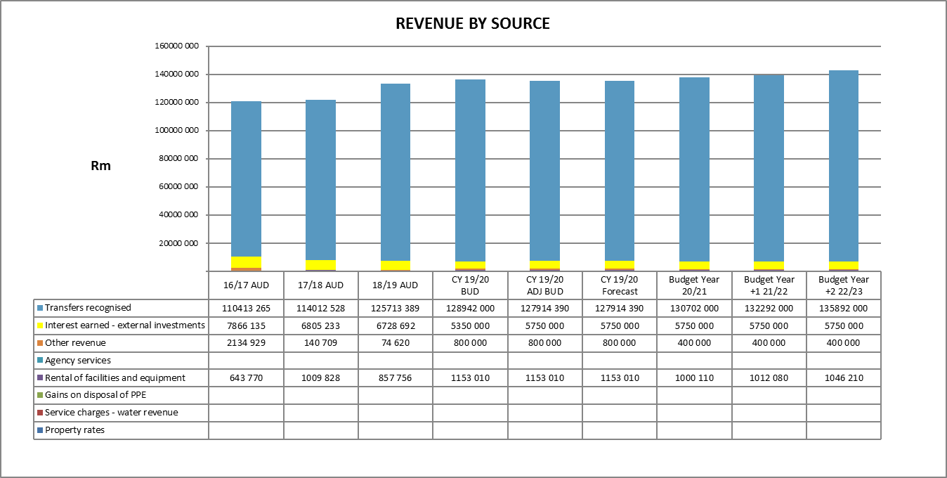
The main source of revenue is still operating grants from government which is 95% of the total revenue. The growth in income is limited to the the current inflation rate and an increase in the GDP that is expected to be 1.2%.
The municipality does not render basic services that can generate revenue.

The following graph indicates the main categories of expenditure for the 2020/21 financial year:
Expenditure by Type – Major:
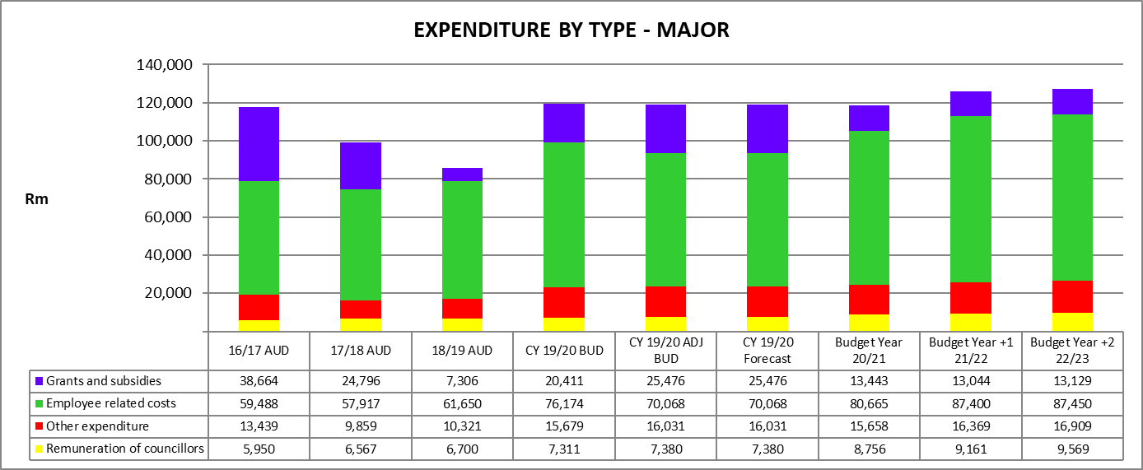
Graph clearly illustrates the decrease trends in grants and subsidies of 47.42% for 20/21 as opposed to 19/20 financial year, this is due to the capital allocation to local municipalities not being budgeted for.
Councillor’s remuneration reflects a fair increase over the past years based on the Remuneration of Public Office Bearers Act, 1998 (Act No. 20 0f 1998) .
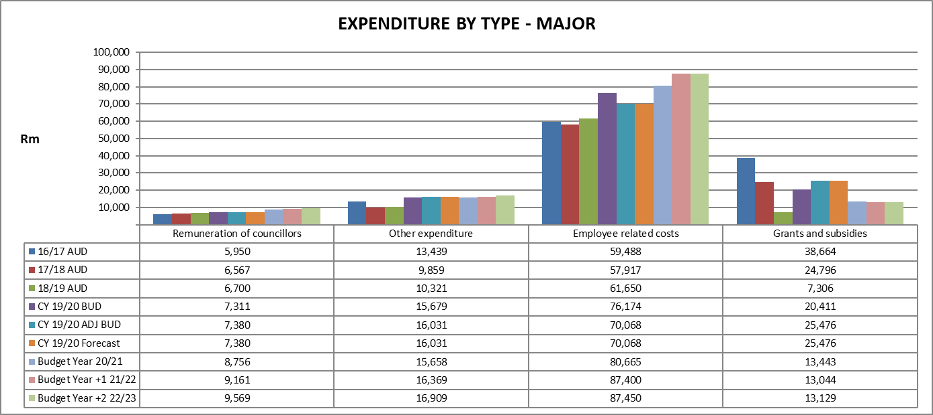

  - Expenditure by Type – Minor:
Expenditure relating to minor expenditure consists mainly of finance charges, depreciation & asset impairment, other materials, loss on disposal of PPE and Debt impairment.
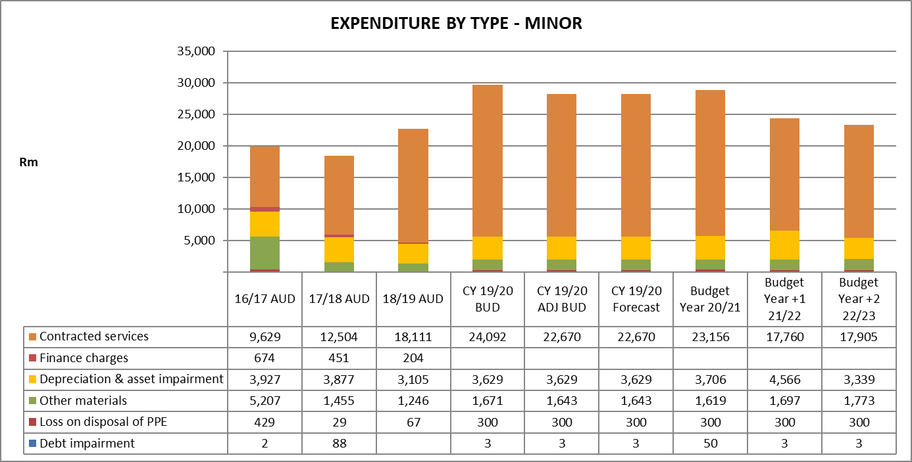

8.6 Capital Expenditure – R8, 7 m
The capital needs of the municipality mainly consists of construction process of fire engine base in Jan Kempdorp and purchasing of the new financial system.
8.7 Capital Expenditure – Funding Source
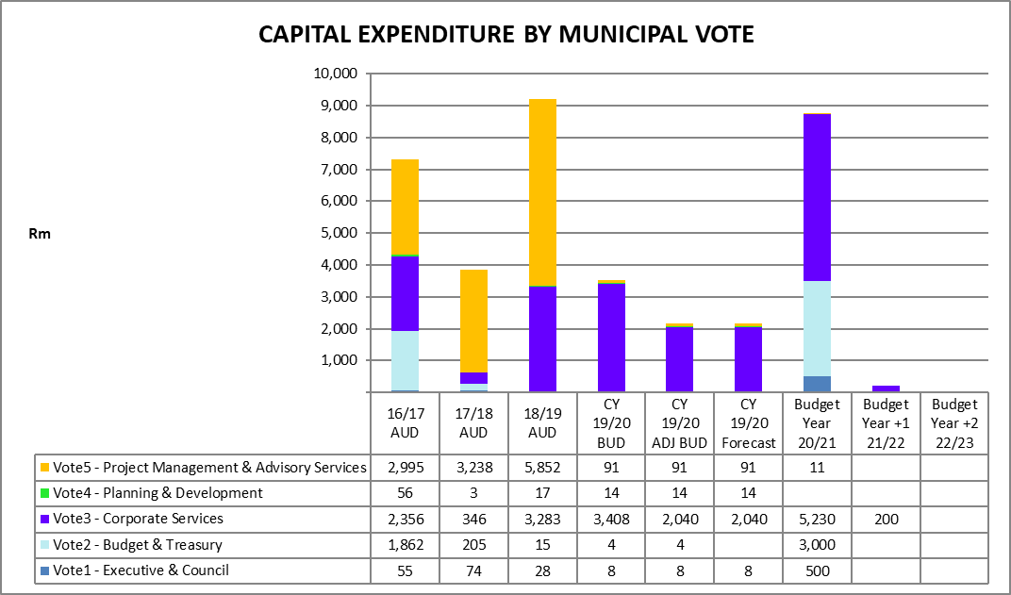
Capital Expenditure is funded from internal funding (Table A5 and SA36).
8.8 Projected Cash Flows
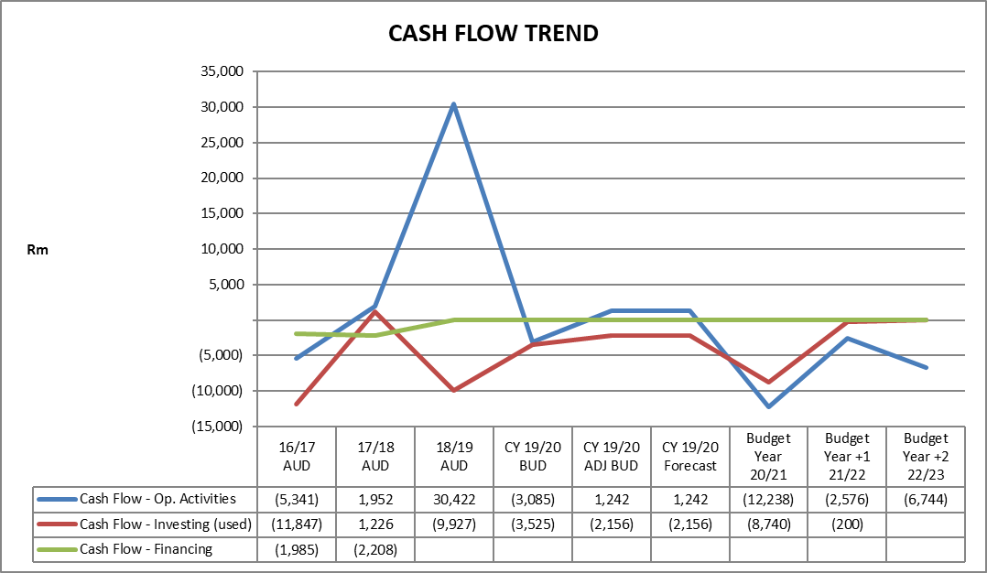
The projected cash flow of the municipality improved from the past years due to the decline in grant and subsidy allocations to the local municipalities.

9. Other
SERVICE DELIVERY AND PROPOSED TARIFFS

Council reviewed and amended its tariff policy in respect of the 2019/20 budget year and the following proposed tariffs was implemented effective from 1 July 2019:
Sundry Charges:
Finance & Administration:-
- Rental of municipal facilities Lecture room: R 1 500.00 per day per room (excluding VAT)
If both 1 & 2 utilised: R 2,500.00 per day (excluding VAT)
Projector required: R 300 per day (excluding VAT)
.
A refundable breakage deposit of 20% of total rent amount.

- Tender Documents – Bids from R200,000 to R500,000: R200-00 non-refundable deposit
(discretion of Municipal Manager)
– Bids from R500, 000 and more dependent on value of the contract non- refundable deposit (discretion of Municipal Manager)

Planning and Development:-
- Rental of Plant & Machinery - Grader R935.00 per hour (excluding VAT)

10. Policies review
In accordance with the MFMA the mayor of a municipality must co-ordinate the processes for preparing the annual budget and for reviewing the municipality’s integrated development plan and budget-related policies to ensure that the tabled budget and any revisions of the integrated development plan and budget-related policies are mutually consistent and credible. Therefore all budget related policies have been reviewed during the course of the financial year and any amendments if necessary will be implemented as an ongoing process during the 2019/20 budget year. The following policies have been classified as budget related:
- Asset management Policy
Approved on 23 September 2015
- Debt and Credit Control Policy
Approved on 29 May 2018
- Tariff Policy
Approved on 29 May 2018
- Investment Policy
Approved on 29 May 2018
- Supply Chain Management Policy
Approved on 29 May 2018
- Budget Policy
Approved on 29 May 2018

